Assignment 2

Scholarship Search Engine

By Spencer Downey

9/13/2020

**Scenario of Use**

Jacob is a high school senior looking to go to college in Alabama or Georgia, but to do so, he needs scholarships to pay for his tuition. He decides to use ScholarshipDatabase.com, a trusted website that allows users to search for scholarships and filter them by state, county, school, and more. When he loads up the website, he is prompted at the top to sign in, or, if he is new, he is prompted to enter in his information, like his grade, current high school, desired colleges, potential major, gender, ethnicity, email, and password. Once he fills out these requirements and submits them, a new page is loaded that contains scholarships he fits the requirements for. This page also has ways to filter the scholarships further, and ways to sort them any way he may need. He can check the scholarships he is interested in applying for, thus adding them to his favorites, and he can start applying for them by clicking the “Apply Now” button. When he clicks “Apply Now”, he is taken to the scholarship’s application page, which contains everything he needs to fill out to apply for the scholarship. While on this page, he can fill out the requirements completely and hit the “Save and Submit” button, or he can fill them out partially or not at all and click the “Save and Exit” button. When he exits the application, he is taken to the “My Scholarships” page that contains his favorited scholarships, his saved applications, and he can also see submitted applications. When Jacob is finished applying for scholarships, he can exit the website and wait for an email response to his applications.

**Empathy Map**

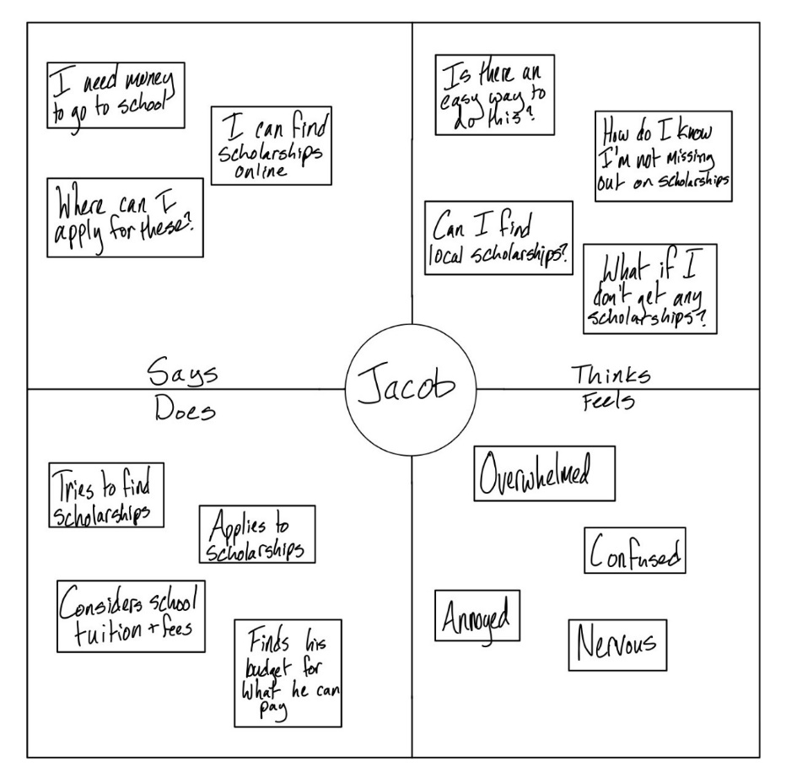

**Personae**

Jacob

Age: 18 Year: Senior Location: Birmingham, AL Gender: Male

* Motivations
  + Jacob is a high school senior excited about going to a school in Alabama or Georgia. He is looking to apply to scholarships because he needs money in order to afford tuition and other fees. Jacob turned to ScholarshipDatabase.com when he discovered the website after doing research and talking to other users.
* Goals
  + To go to the college he wants
  + To cover as much tuition as possible with scholarships
  + To apply to and receive scholarships in an efficient way
* Frustrations
  + Finding a trustworthy website
  + Struggling to find enough scholarships to apply for
  + Not knowing what scholarships apply to him

**Hardware and Software Requirements**

* Hardware
  + Designed on a PC with Windows 10
  + Has the ability to design UI for multiple platforms, so this mock UI could be adapted to other platforms.
  + MockFlow requires a minimum of 4 GB RAM when creating large wireframe projects
* Software:
  + Google Chrome (Recommended), Safari, Mozilla Firefox, or any other web browser
  + Windows 7, 8, 8.1, 10 or later. For Mac, use OS X Yosemite 10.10 or later
  + MockFlow

**Interface Metaphor & Interaction Type**

* Interface Metaphor
  + Web Portal
* Interaction type
  + Instruction – mainly just asking questions/prompts and getting them to select or type an answer or response

**Webpages**

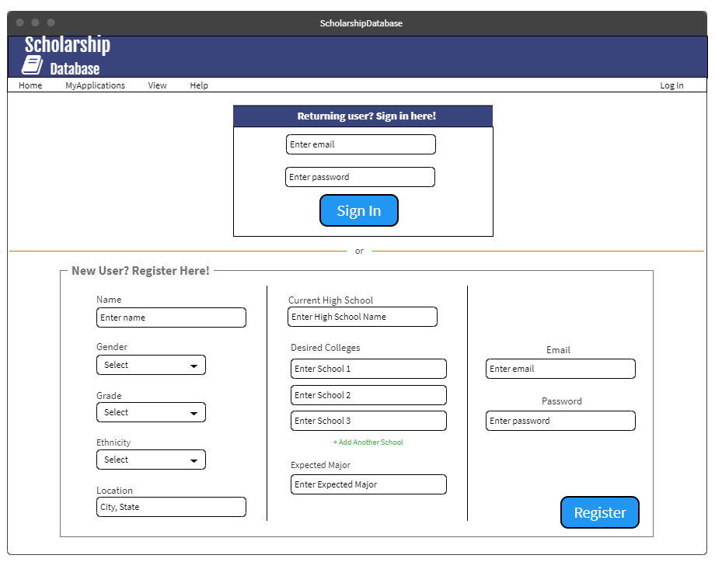

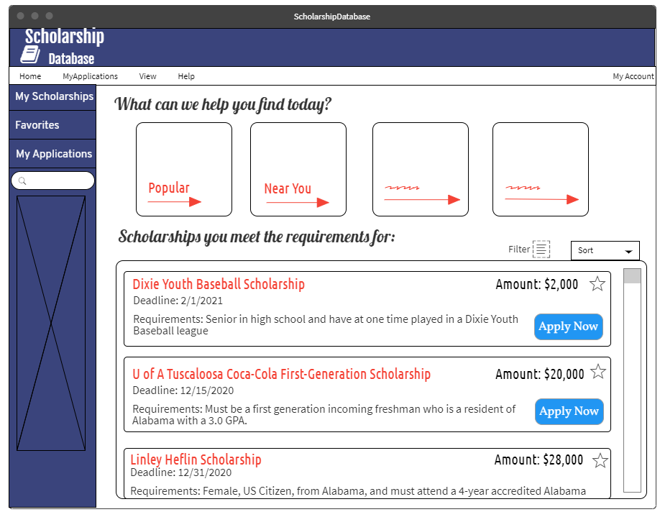

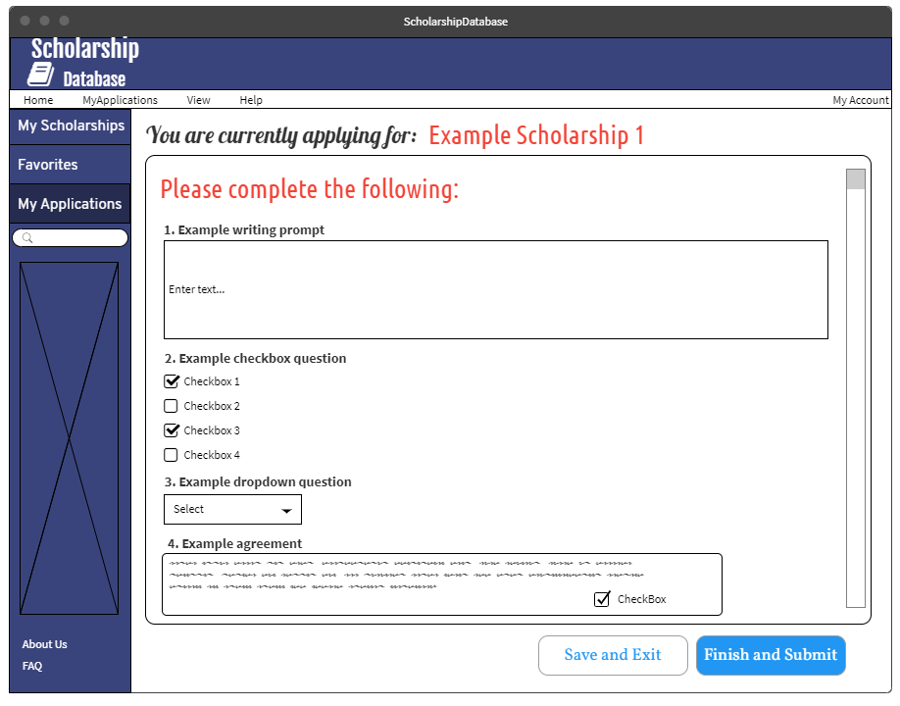

**Dixie Youth Baseball Scholarship**: <https://www.scholarships.com/financial-aid/college-scholarships/scholarships-by-state/alabama-scholarships/dixie-youth-baseball-scholarship/>

**U of A Tuscaloosa Coca Cola First Generation Sholarship:** <https://www.scholarships.com/financial-aid/college-scholarships/scholarships-by-state/alabama-scholarships/u-of-a-tuscaloosa-coca-cola-first-generation-scholarship/>

**Linly Heflin Scholarship:** https://www.scholarships.com/financial-aid/college-scholarships/scholarships-by-state/alabama-scholarships/linly-heflin-scholarship/